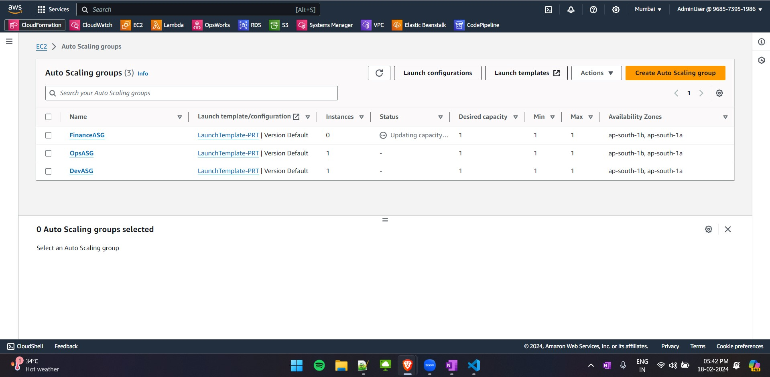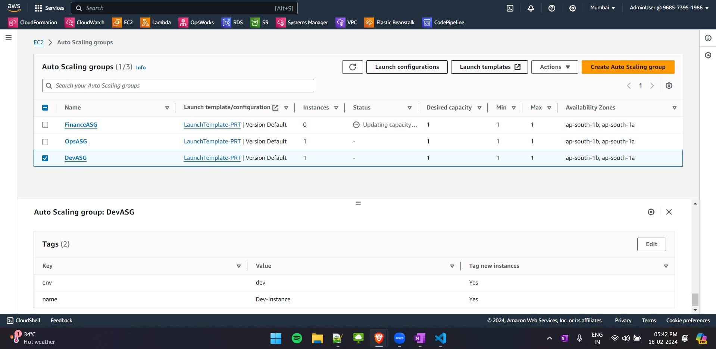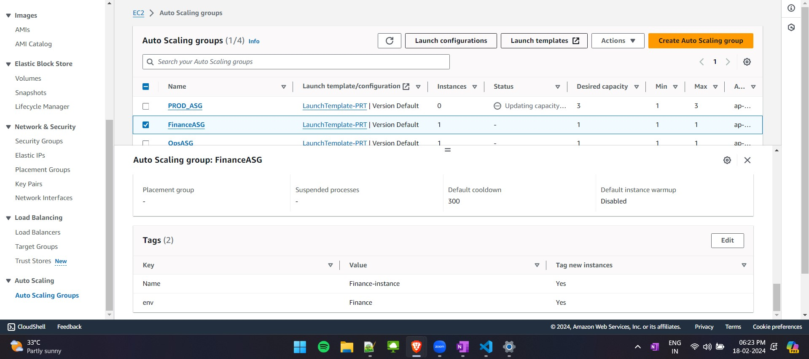

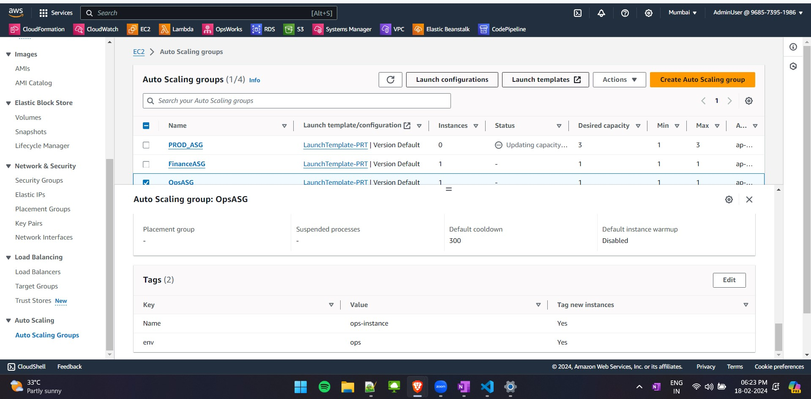

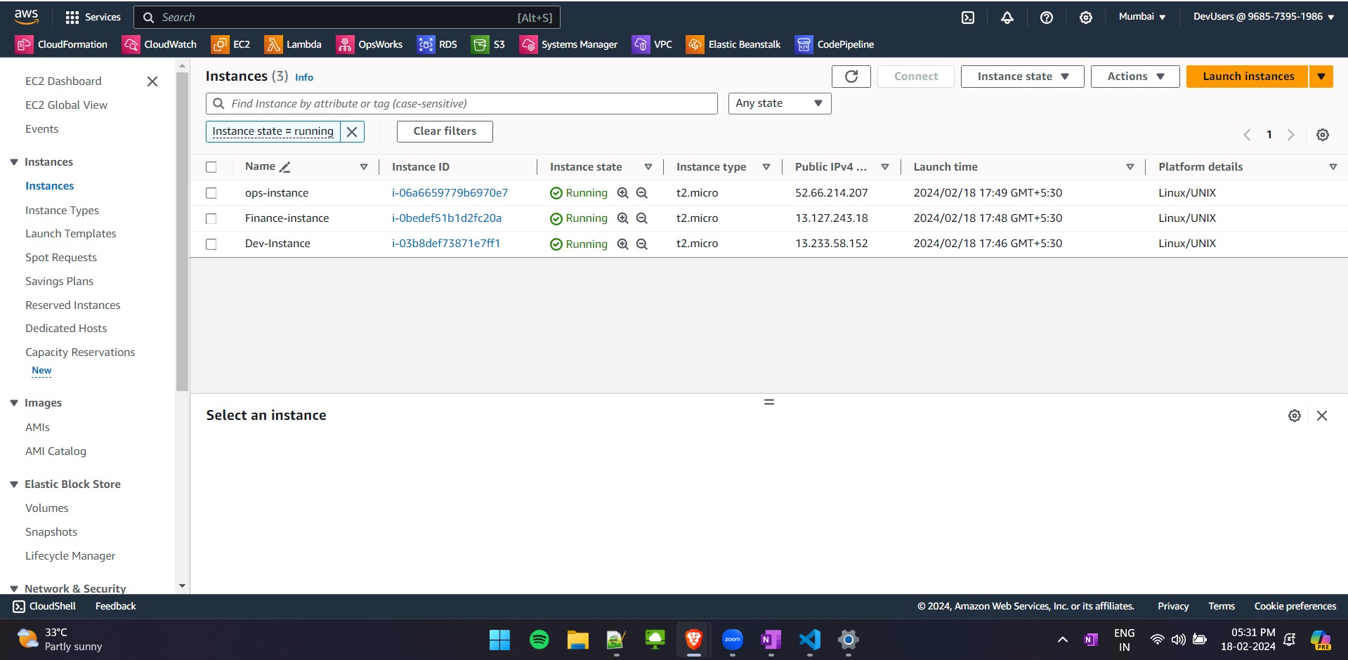

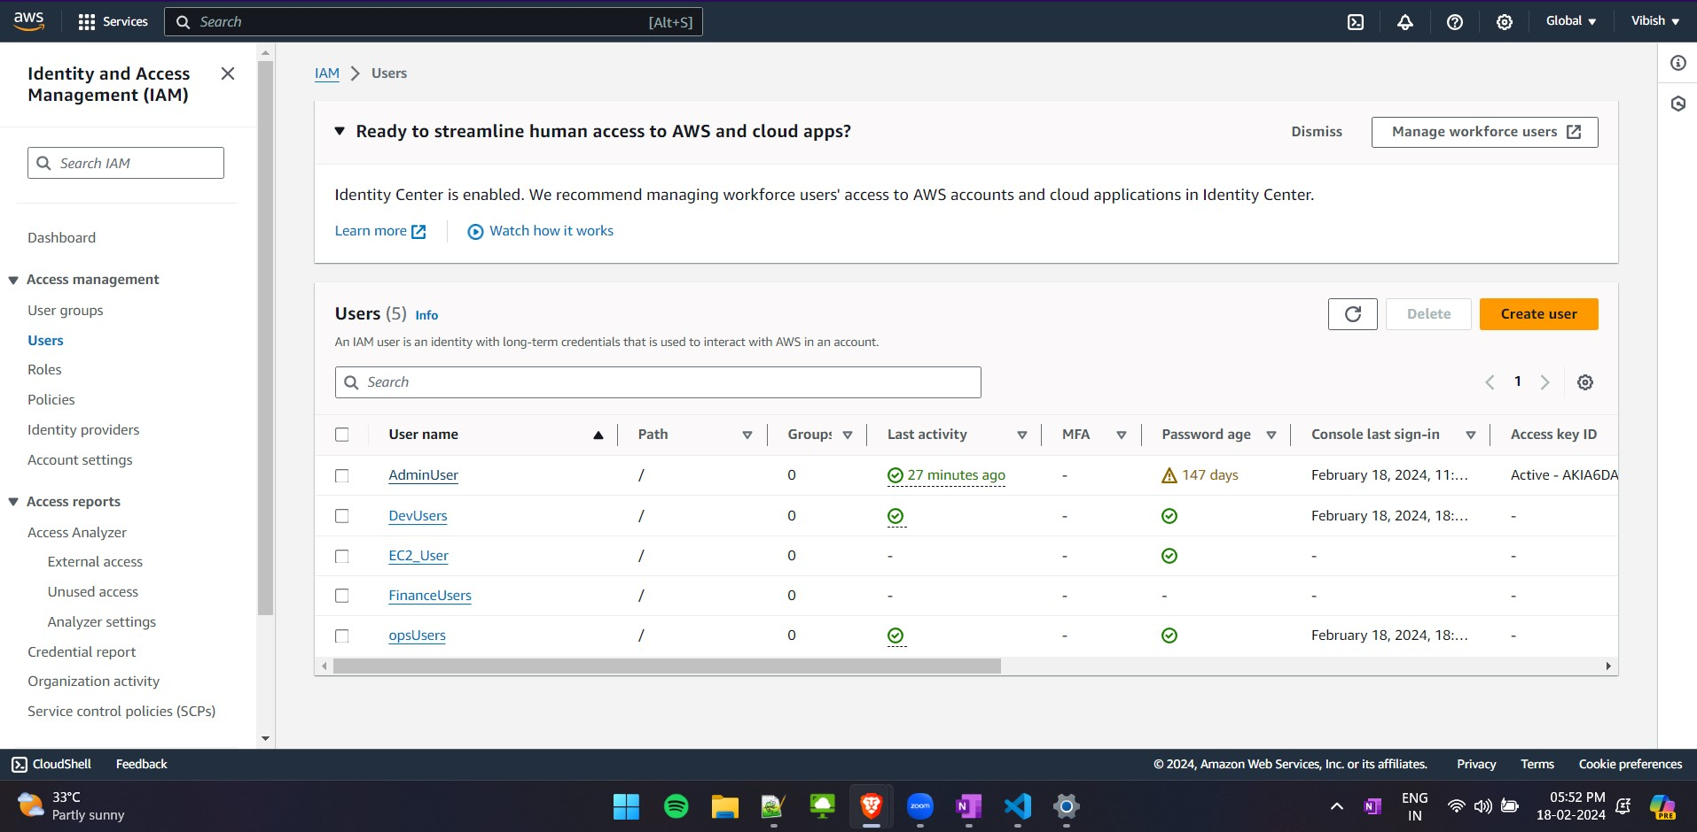

Sample IM for Dev:

{

"Version": "2012-10-17",

"Statement": [

{

"Effect": "Allow",

"Action": [

"ec2:Describe*",

"ec2:Get*",

"ec2:List*"

],

"Resource": "*"

},

{

"Effect": "Allow",

"Action": [

"ec2:StartInstances",

"ec2:StopInstances",

"ec2:RebootInstances",

"ec2:TerminateInstances",

"ec2:ModifyInstanceAttribute",

"ec2-instance-connect:SendSSHPublicKey"

],

"Resource": "arn:aws:ec2:*:*:instance/*",

"Condition": {

"StringLike": {

"ec2:ResourceTag/env": "dev"

}

}

}

]

}

Sample IM for EC2User:

{

"Version": "2012-10-17",

"Statement": [

{

"Sid": "Statement1",

"Effect": "Allow",

"Action": [

"ec2:*"

],

"Resource": [

"*"

]

},

{

"Sid": "Statement2",

"Effect": "Deny",

"Action": [

"ec2-instance-connect:SendSSHPublicKey"

],

"Resource": [

"*"

]

}

]

}

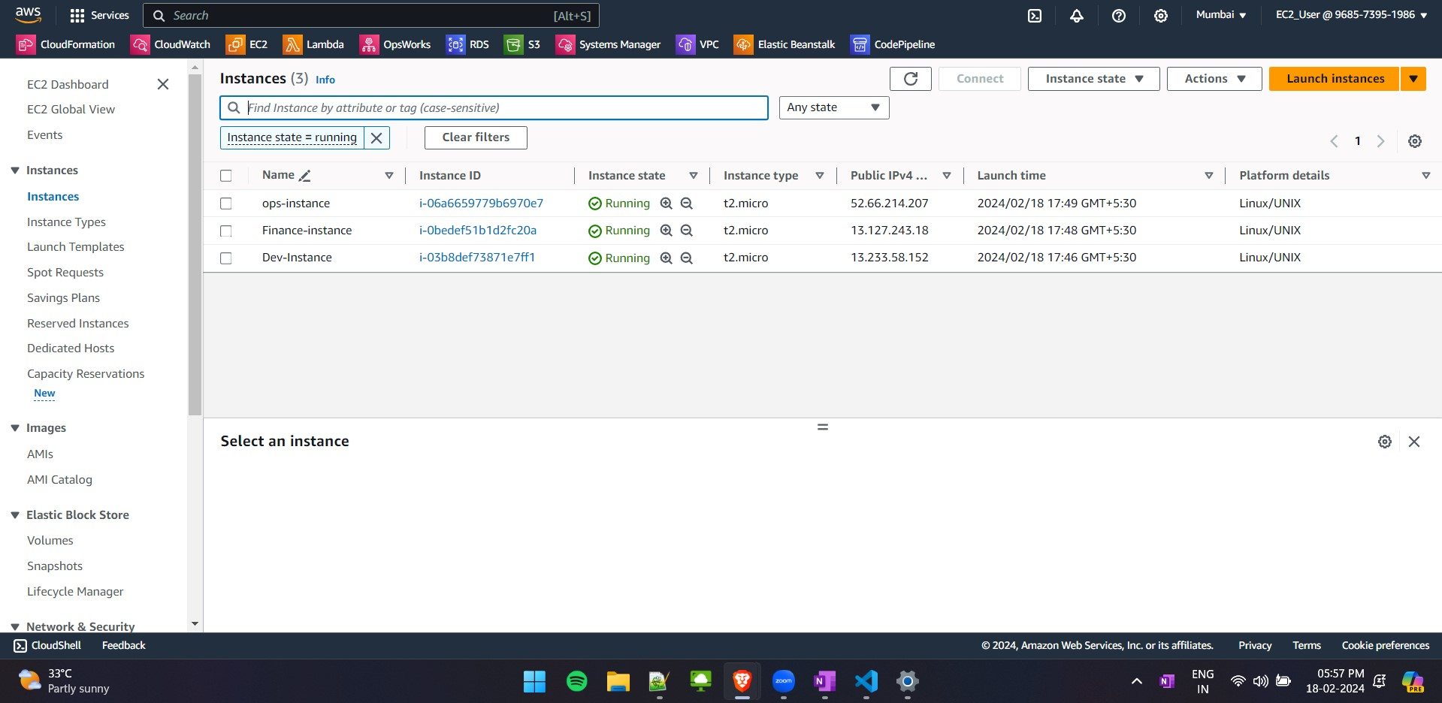

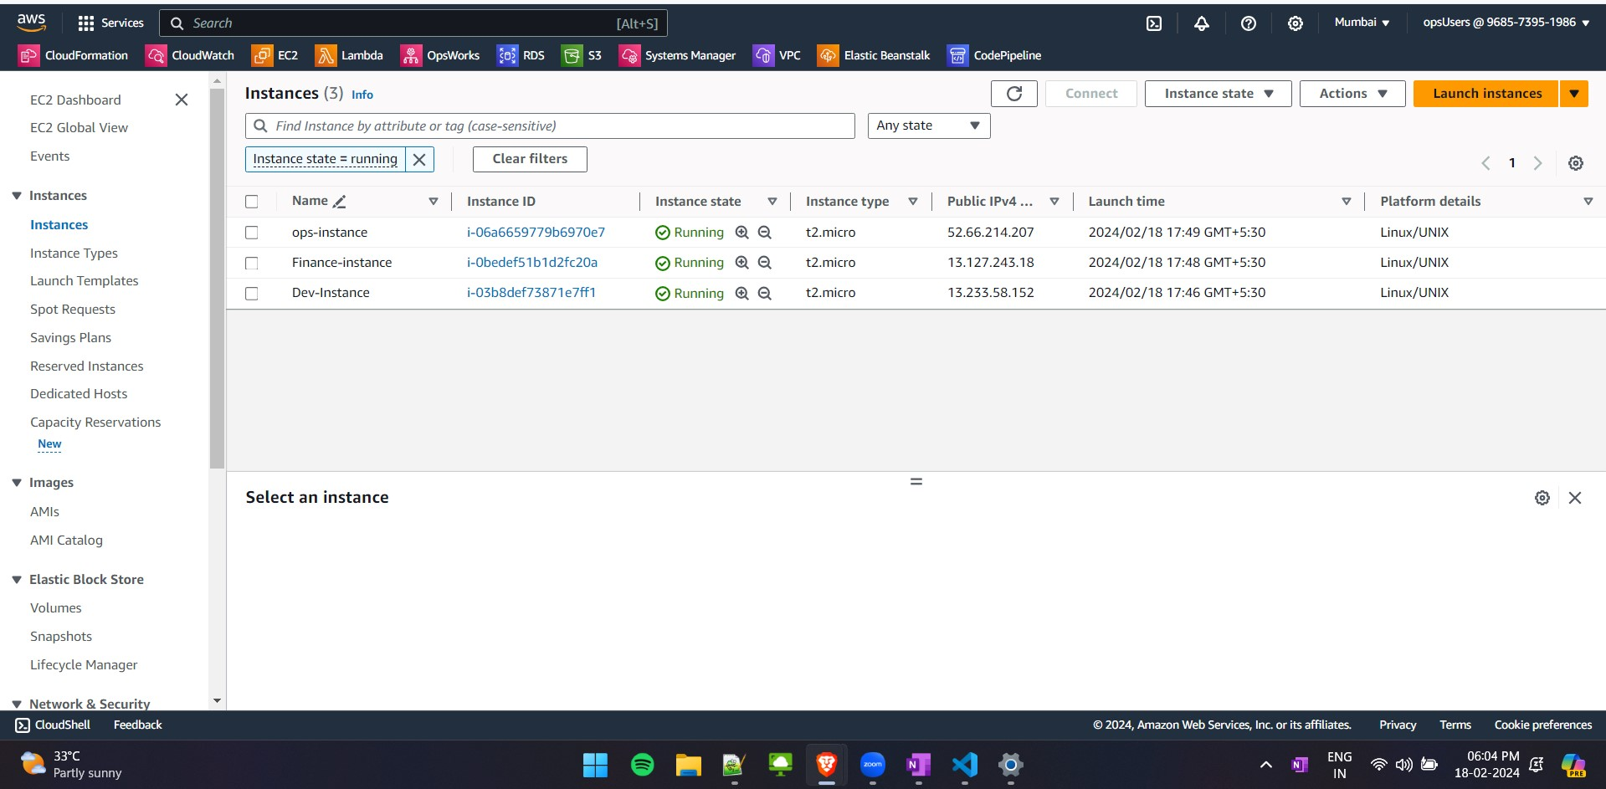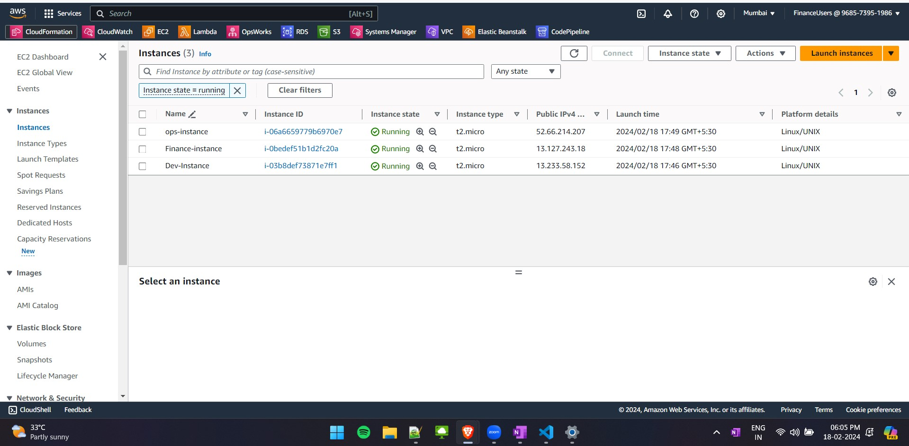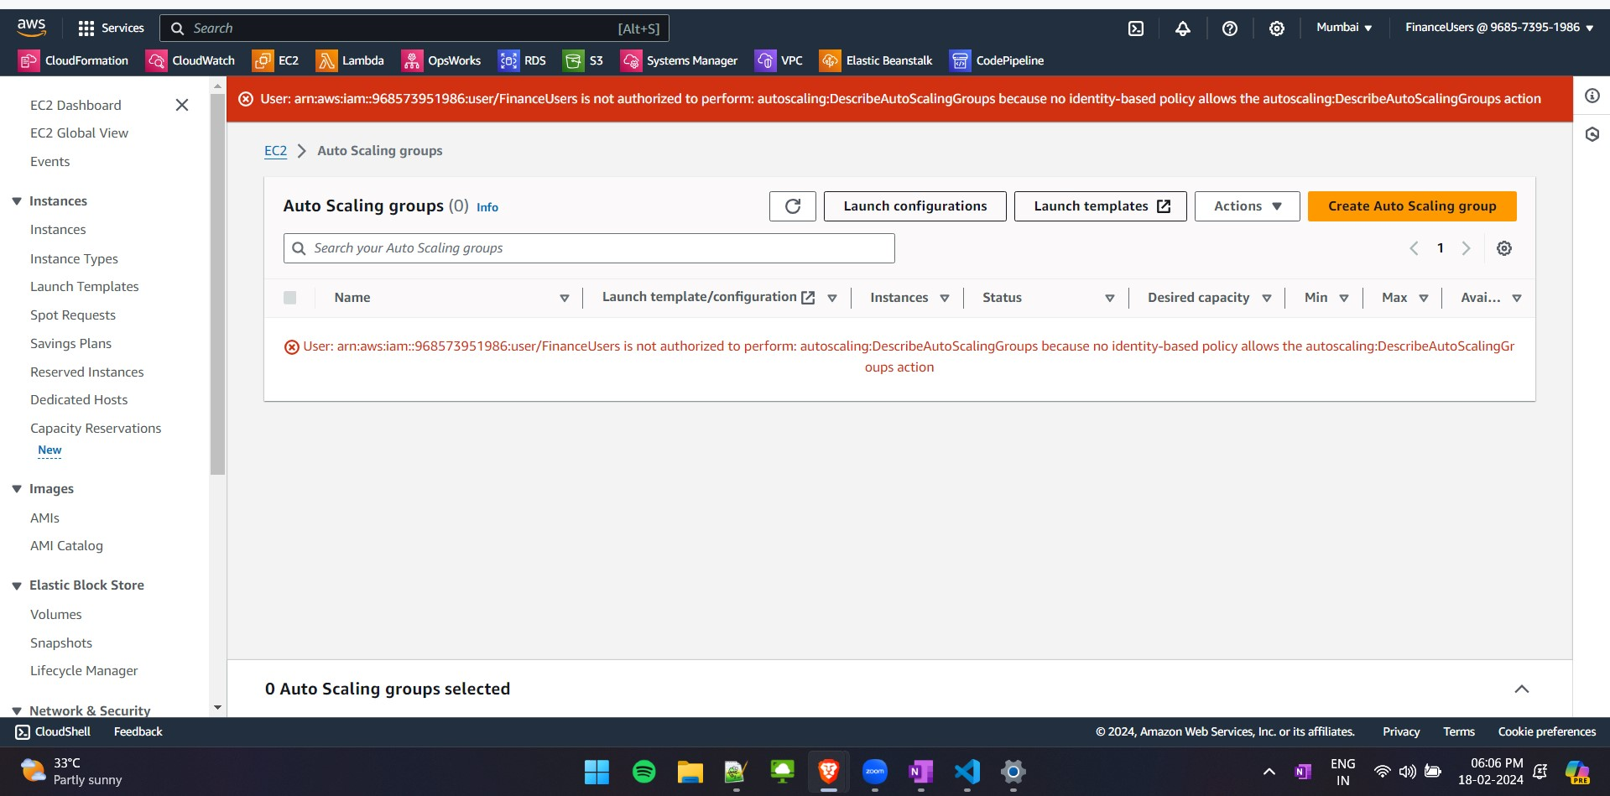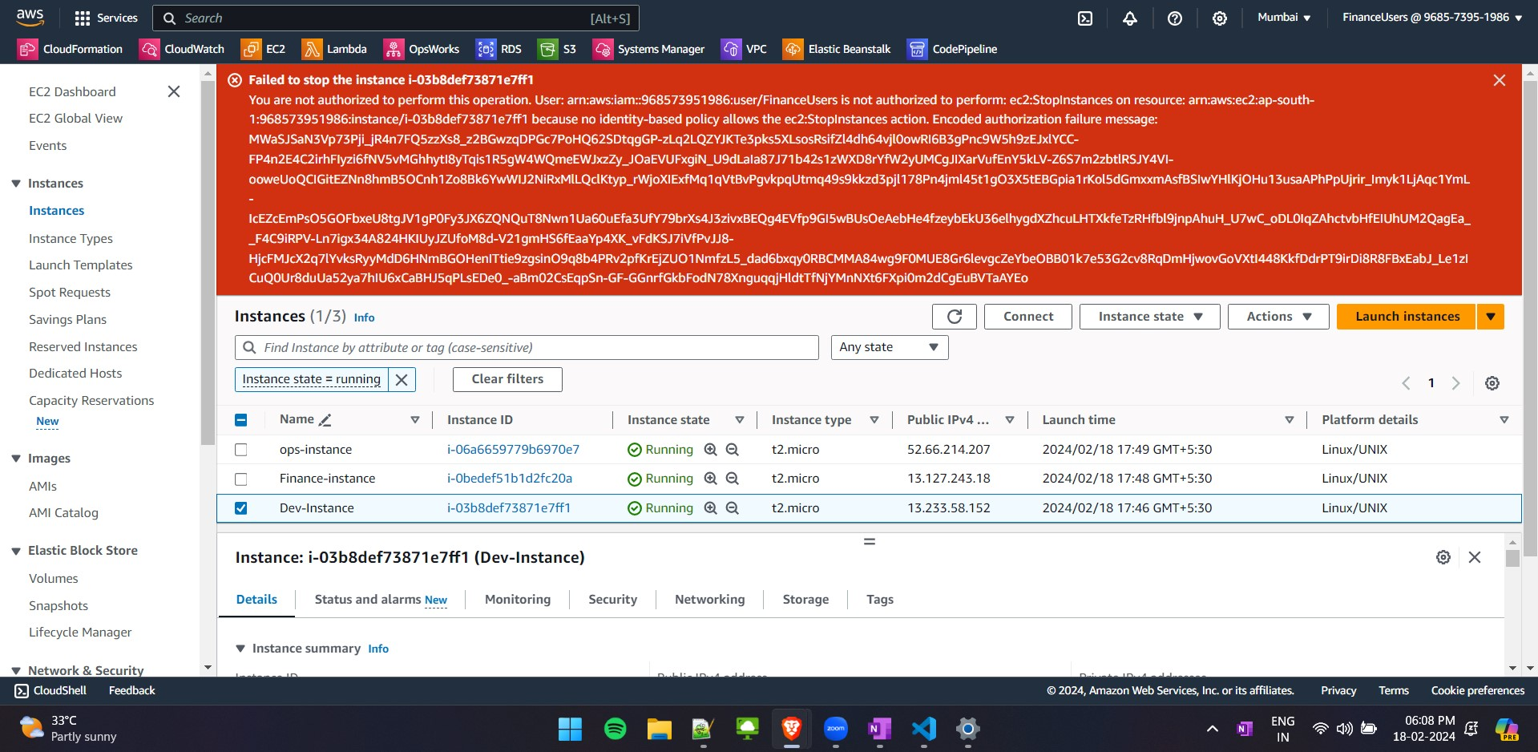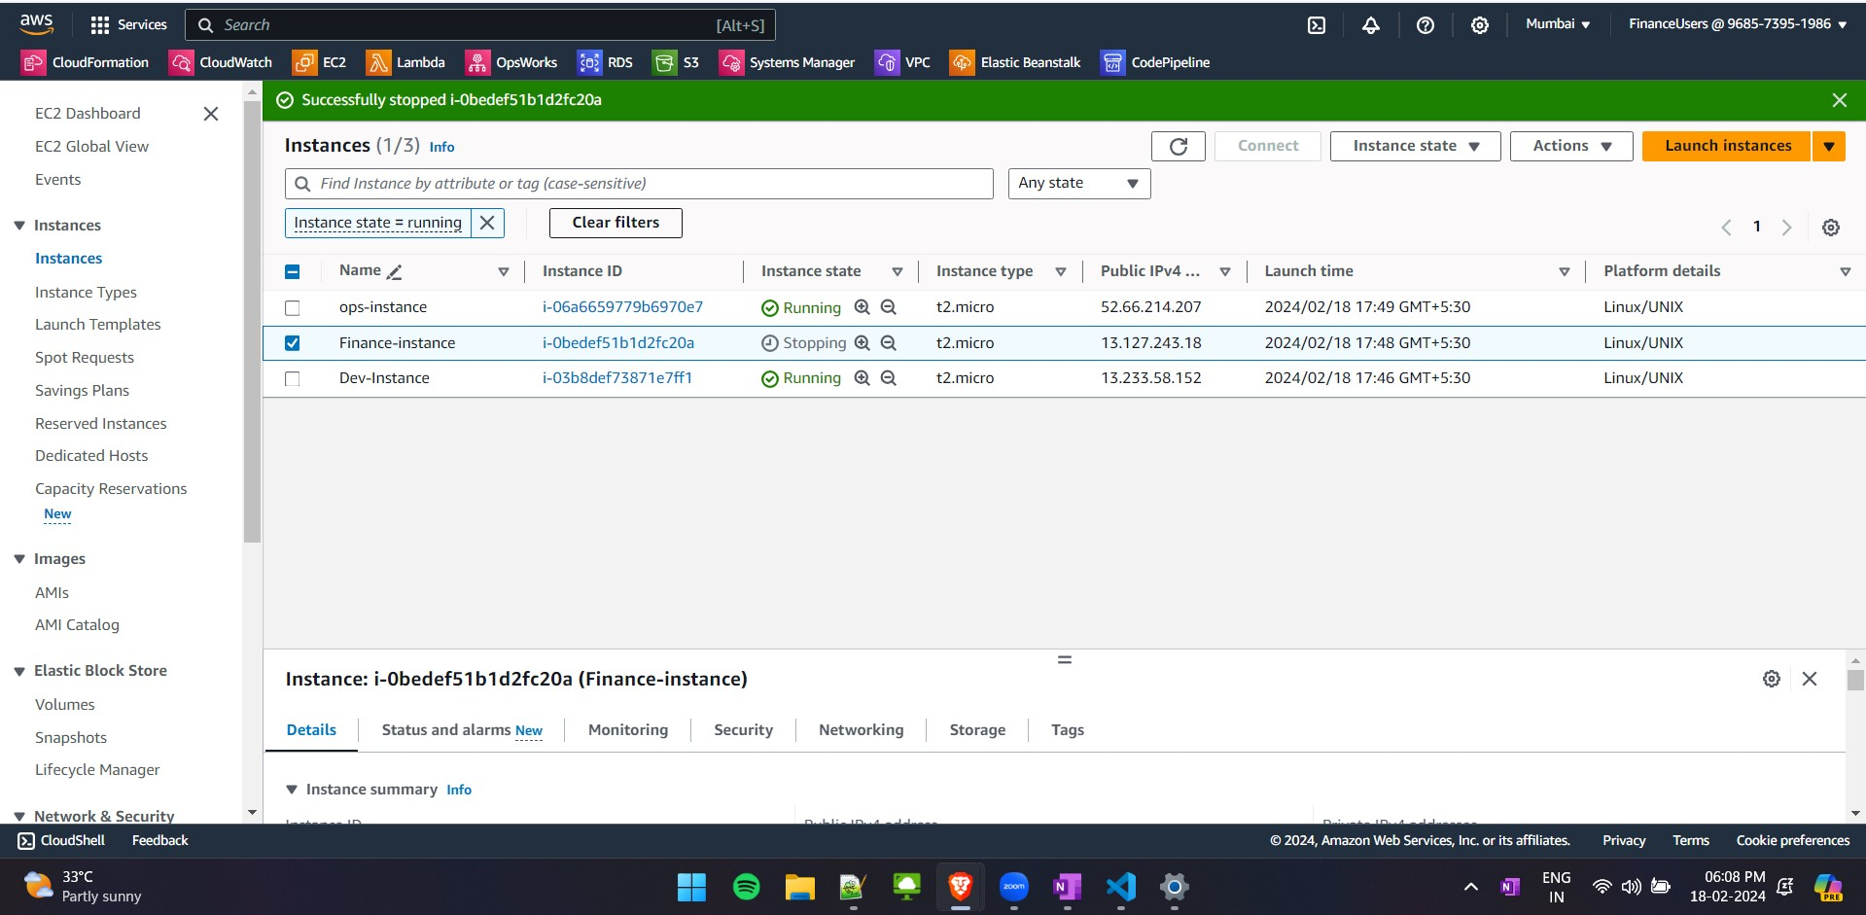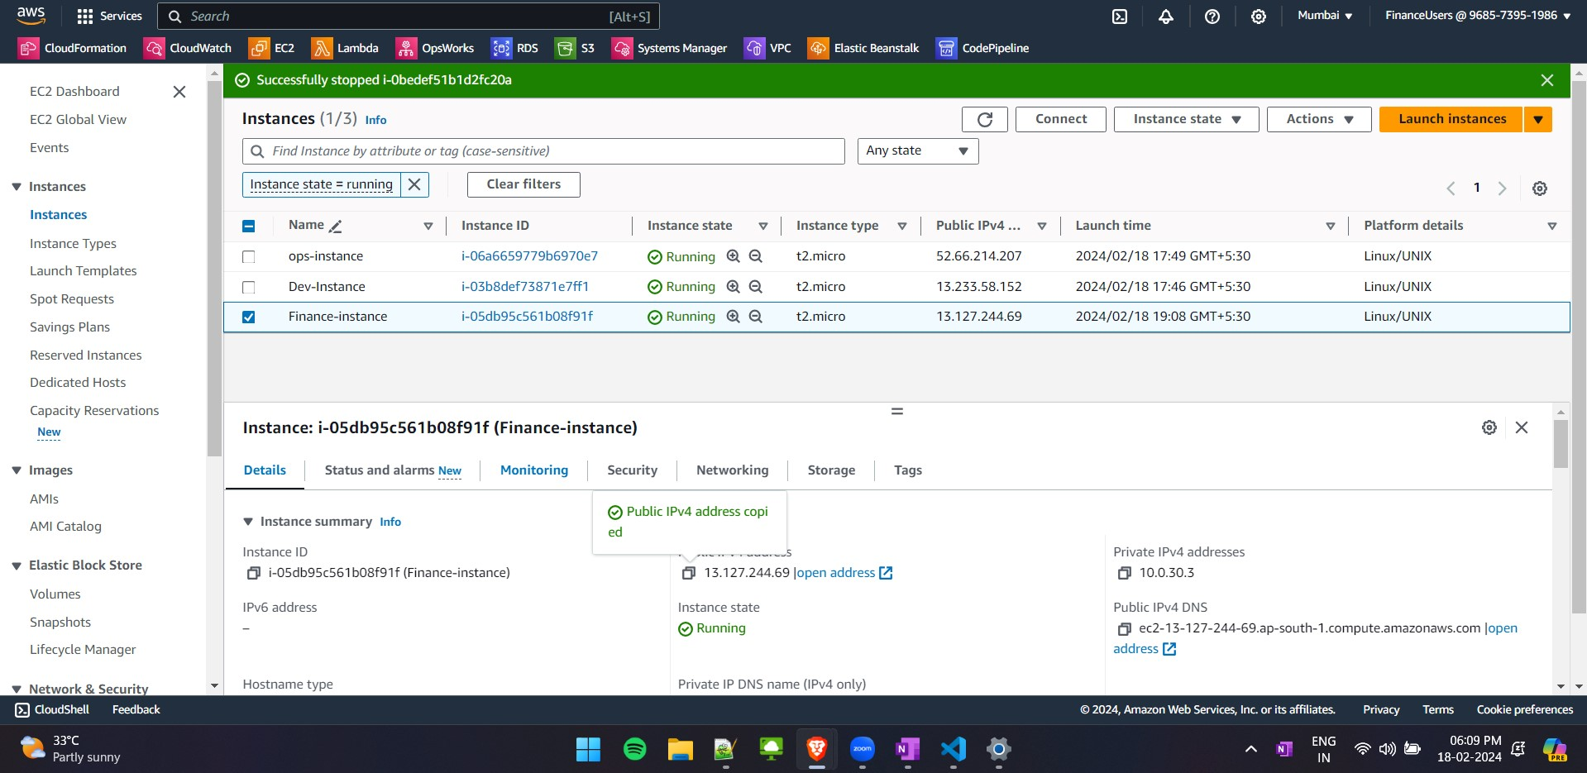

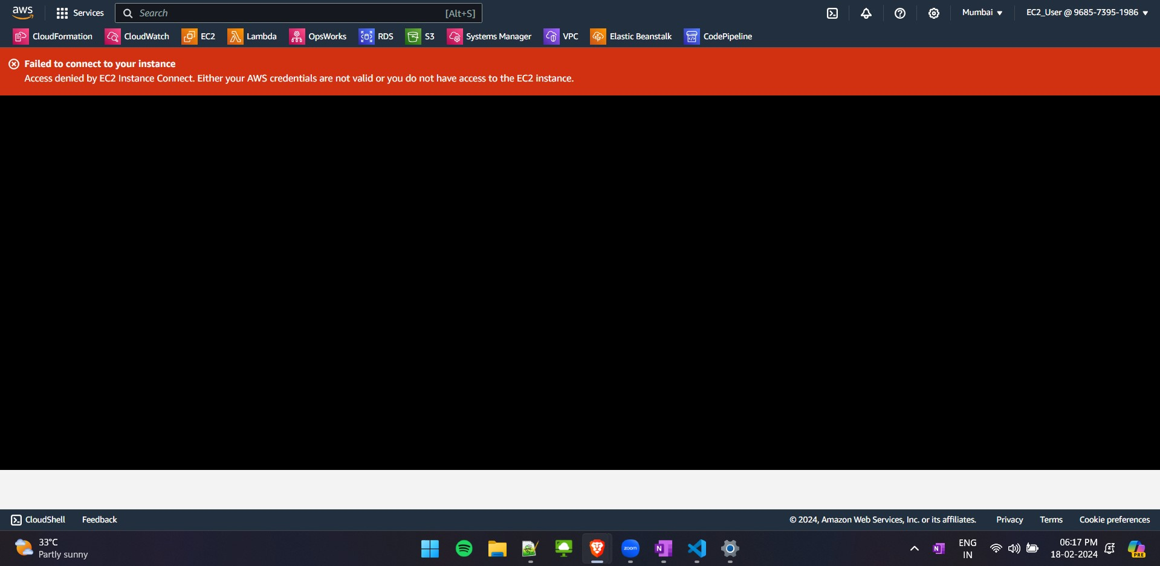

UserData:

#!/bin/bash

# Mount EFS

mkdir /mnt/efs mount -t efs fs-23416578:/ /mnt/efs

# Install Apache HTTP Server yum install -y httpd

# Create index.html with "Hello from EC2 User" echo "Hello from EC2 User" > /var/www/html/index.html

# Start Apache systemctl start httpd systemctl enable httpd

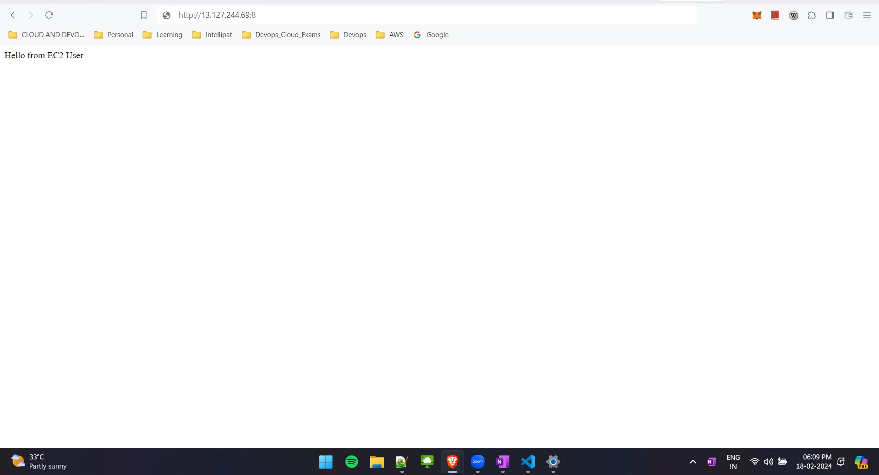

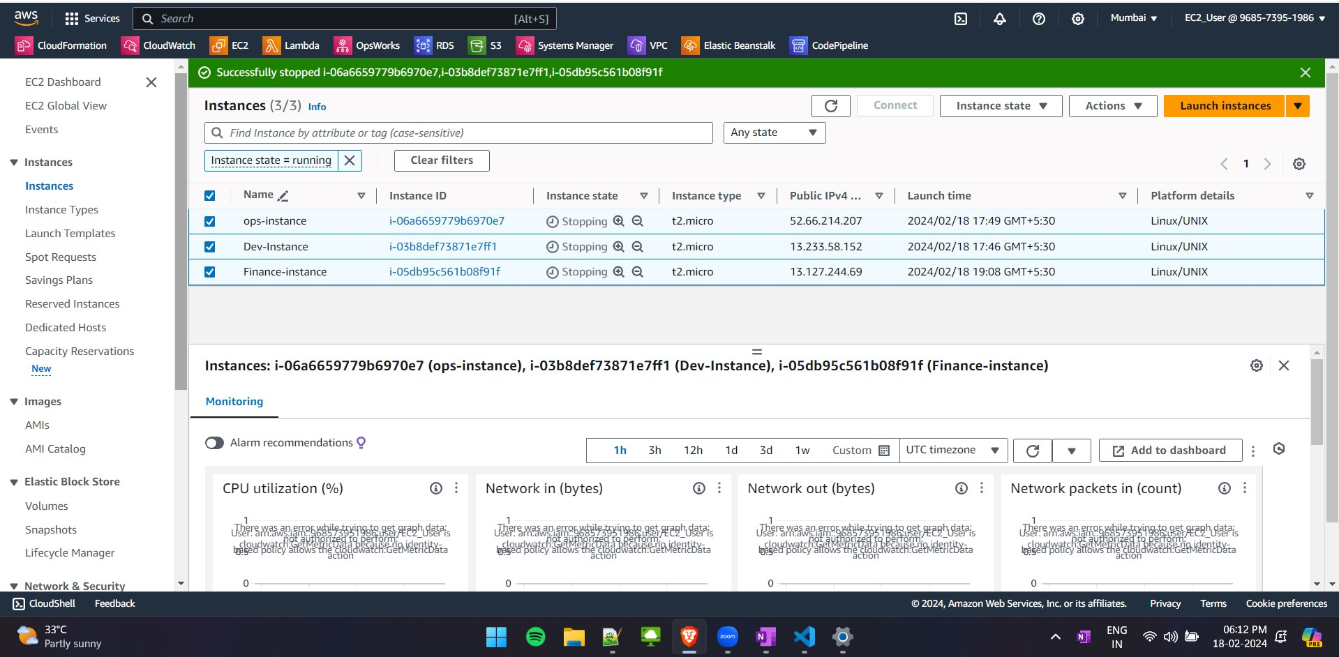

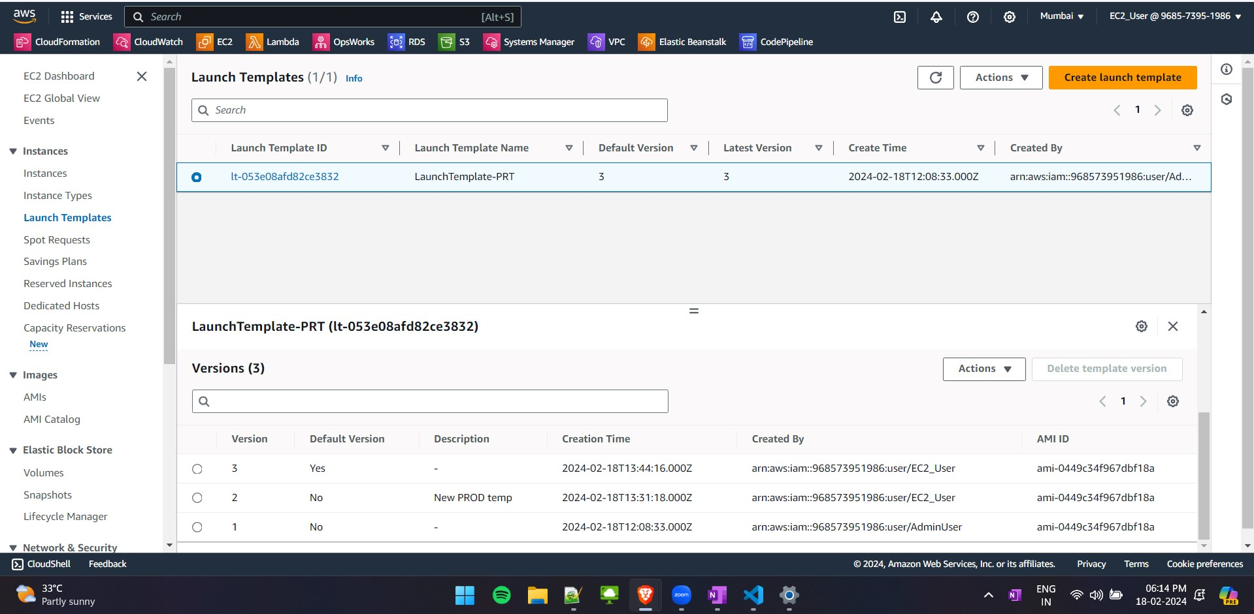

For Prod this is modified to this and made it to default

echo "Hello from EC2 User" > /var/www/html/index.html —> echo "Hello from $(hostname

-f)" > /var/www/html/index.html

